IMPORT DATA USING TRANSFORM MAPS(SPREADSHEET)
1. INTRODUCTION
1.1 Projects:
The project titled “Importing Data Using Transform Maps (Spreadsheet) in ServiceNow” focuses on automating and streamlining the data ingestion process from external spreadsheets into ServiceNow staging and target tables. In many organizations, managing master data, user records, configuration items (CIs), or transactional logs often involves manual data entry or repetitive import steps. These manual operations are prone to human errors, data inconsistencies, format mismatches, and significant administrative delays.
To resolve these operational challenges, this project utilizes ServiceNow's native Import Sets and Transform Maps functionality. A Transform Map is a robust mechanism that allows administrators to establish specific relationships and mapping rules between fields in an imported spreadsheet (source table) and fields in a destination ServiceNow table. It enables low-code data transformation, ensuring that incoming data matches the required schema and business logic without complex integration scripting.
The proposed system simplifies bulk data onboarding by automating data validation, field-to-field mapping, and coalesce rules (to prevent duplicate records). When a user uploads a spreadsheet, the system parses the data into an import set table, applies the configured transform map, and populates the target tables seamlessly. By implementing this solution, organizations can eliminate manual database updates, maintain high data integrity, accelerate data migration tasks, and improve overall platform efficiency.
1.2 purpose:
The primary purpose of this project is to standardize and accelerate the bulk data import process in ServiceNow using Transform Maps. The project aims to deliver a reliable, automated pipeline for migrating and managing spreadsheet data while ensuring strict validation and deduplication rules.
• Automate Bulk Imports: Eliminate manual row-by-row data entry by processing large-scale spreadsheets instantly through import sets.
• Define Data Mapping: Establish clear structural relationships between Excel/CSV column headers and ServiceNow table fields.
• Prevent Duplicate Records: Utilize coalesce fields to match existing records, performing updates instead of creating duplicates.
• Cleanse Data On-The-Fly: Run transformation scripts to format dates, strings, and reference values during the import process.
• Reduce Human Error: Minimize manual database tampering and typos by automating data transformation rules.
• Provide Import Visibility: Leverage transform history logs to track successful inserts, updates, errors, and skipped rows.
2. IDEATION PHASE
2.1 Problem Statement
Define the Problem Statements
Date | 31 January 2025
Team ID

Project Name

Maximum Marks | 2 Marks

Customer Problem Statement Template:
Create a problem statement to understand your customer's point of view. The Customer Problem Statement template helps you focus on what matters to create experiences people will love.
A well-articulated customer problem statement allows you and your team to find the ideal solution for the challenges your customers face. Throughout the process, you’ll also be able to empathize with your customers, which helps you better understand how they perceive your product or service.

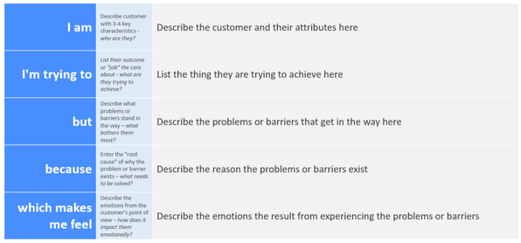

Reference: https://miro.com/templates/customer-problem-statement/

Example:

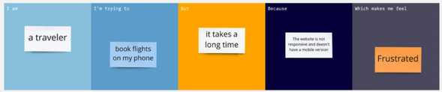

Problem Statement (PS) | I am (Customer) | I’m trying to | But | Because | Which makes me feel
PS-1

PS-2

2.2 Empathy Map Canvas

Empathize & Discover

Empathy Map Canvas:
An empathy map is a simple, easy-to-digest visual that captures knowledge about a user’s behaviours and attitudes.

It is a useful tool to helps teams better understand their users.
Creating an effective solution requires understanding the true problem and the person who is experiencing it. The exercise of creating the map helps participants consider things from the user’s perspective along with his or her goals and challenges.
Example:

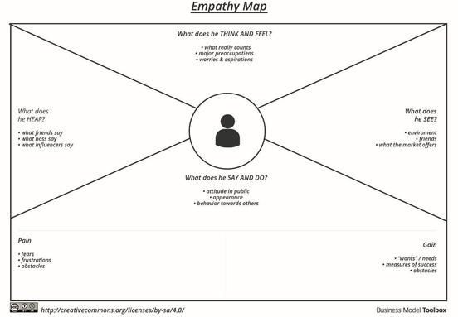

Reference: https://www.mural.co/templates/empathy-map-canvas

Example: Food Ordering & Delivery Application

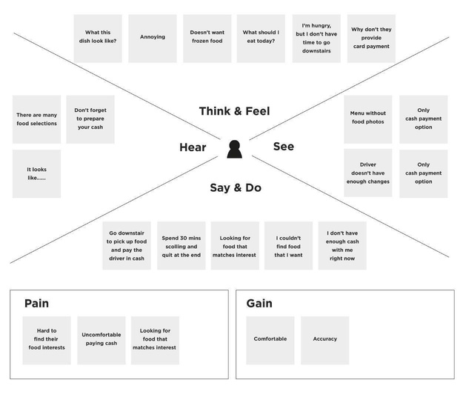

2.3 Brainstorming
Brainstorm & Idea Prioritization Template

Date | 31 January 2025
Team ID

Project Name

Maximum Marks | 4 Marks

Brainstorm & Idea Prioritization Template:
Brainstorming provides a free and open environment that encourages everyone within a team to participate in the creative thinking process that leads to problem solving. Prioritizing volume over value, out-of-the-box ideas are welcome and built upon, and all participants are encouraged to collaborate, helping each other develop a rich amount of creative solutions.
Use this template in your own brainstorming sessions so your team can unleash their imagination and start shaping concepts even if you're not sitting in the same room.
Reference: https://www.mural.co/templates/brainstorm-and-idea-prioritization
Step-1: Team Gathering, Collaboration and Select the Problem Statement

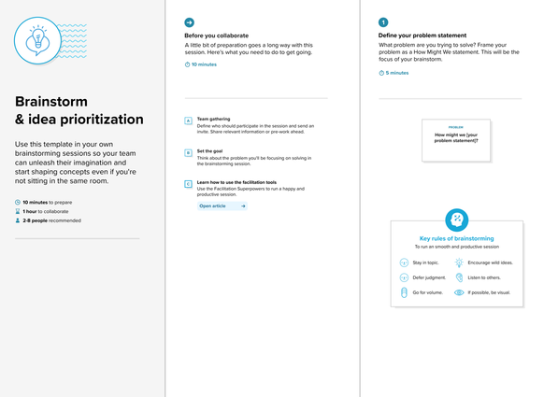

Step-2: Brainstorm, Idea Listing and Grouping

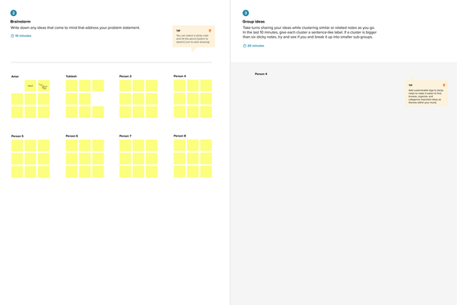

Step-3: Idea Prioritization

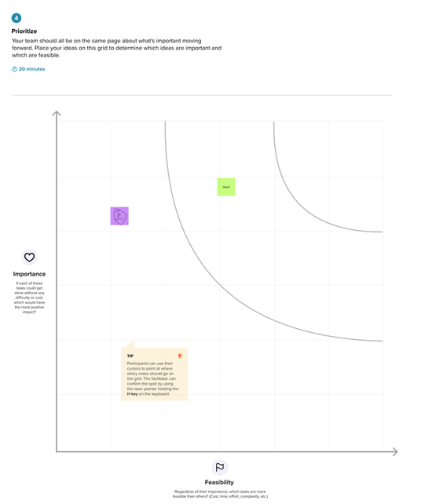

3. REQUIREMENT ANALYSIS
3.1 Customer Journey Map

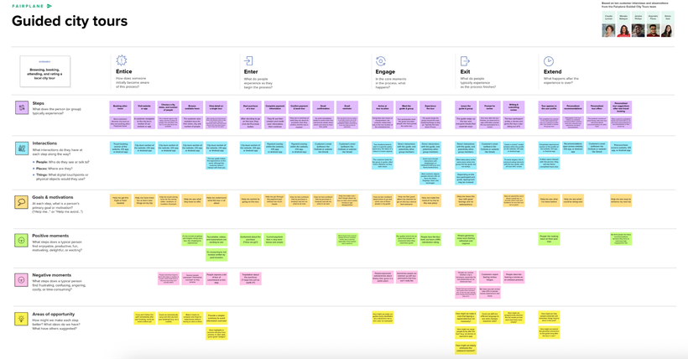

3.2 Solution Requirement
Solution Requirements (Functional & Non-functional)

Functional Requirements:
Following are the functional requirements of the proposed solution.

Non-functional Requirements:
Following are the non-functional requirements of the proposed solution.

3.3 Data Flow Diagram
Data Flow Diagram & User Stories

Date | 31 January 2025
Team ID

Project Name

Maximum Marks | 4 Marks

Data Flow Diagrams:
A Data Flow Diagram (DFD) is a traditional visual representation of the information flows within a system. A neat and clear DFD can depict the right amount of the system requirement graphically. It shows how data enters and leaves the system, what changes the information, and where data is store.

Example: (Simplified)
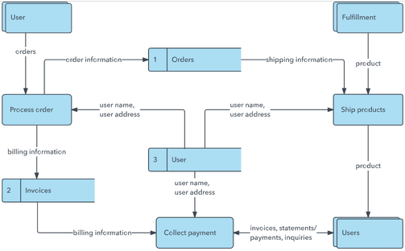

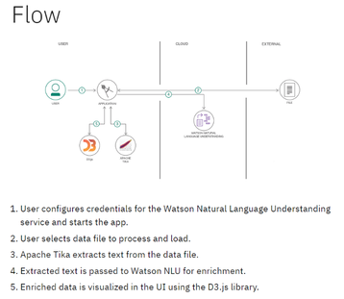

User Stories
Use the below template to list all the user stories for the product.
User Type | Functional Requirement (Epic) | User Story Number | User Story / Task | Acceptance criteria | Priority | Release
Customer (Mobile user) | Registration | USN-1 | As a user, I can register for the application by entering my email, password, and confirming my password. | I can access my account / dashboard | High | Sprint-1
 |  | USN-2 | As a user, I will receive confirmation email once I have registered for the application | I can receive confirmation email & click confirm | High | Sprint-1
 |  | USN-3 | As a user, I can register for the application through Facebook | I can register & access the dashboard with Facebook Login | Low | Sprint-2
 |  | USN-4 | As a user, I can register for the application through Gmail |  | Medium | Sprint-1
 | Login | USN-5 | As a user, I can log into the application by entering email & password |  | High | Sprint-1
 | Dashboard
Customer (Web user)

Customer Care Executive

Administrator

3.4 Technology Stack
Technology Stack (Architecture & Stack)

Date | 31 January 3035
Team ID

Project Name

Maximum Marks | 4 Marks

Technical Architecture:
The Deliverable shall include the architectural diagram as below and the information as per the table1 & table 2

Example: Order processing during pandemics for offline modeReference:
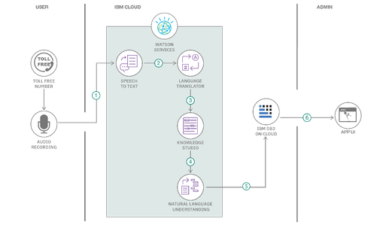

Table-1 : Components & Technologies:
S.No | Component | Description | Technology
 | User Interface | How user interacts with application e.g.  Web UI, Mobile App, Chatbot etc. | HTML, CSS, JavaScript / Angular Js / React Js etc.
 | Application Logic-1 | Logic for a process in the application | Java / Python
 | Application Logic-2 | Logic for a process in the application | IBM Watson STT service
 | Application Logic-3 | Logic for a process in the application | IBM Watson Assistant
 | Database | Data Type, Configurations etc. | MySQL, NoSQL, etc.
 | Cloud Database | Database Service on Cloud | IBM DB2, IBM Cloudant etc.
 | File Storage | File storage requirements | IBM Block Storage or Other Storage Service or Local Filesystem
 | External API-1 | Purpose of External API used in the application | IBM Weather API, etc.
 | External API-2 | Purpose of External API used in the application | Aadhar API, etc.
 | Machine Learning Model | Purpose of Machine Learning Model | Object Recognition Model, etc.
 | Infrastructure (Server / Cloud) | Application Deployment on Local System / Cloud  Local Server Configuration:  Cloud Server Configuration : | Local, Cloud Foundry, Kubernetes, etc.

Table-2: Application Characteristics:
S.No | Characteristics | Description | Technology
 | Open-Source Frameworks | List the open-source frameworks used | Technology of Opensource framework
 | Security Implementations | List all the security / access controls implemented, use of firewalls etc. | e.g. SHA-256, Encryptions, IAM Controls, OWASP etc.
 | Scalable Architecture | Justify the scalability of architecture (3 – tier, Micro-services) | Technology used
 | Availability | Justify the availability of application (e.g. use of load balancers, distributed servers etc.) | Technology used
 | Performance | Design consideration for the performance of the application (number of requests per sec, use of Cache, use of CDN’s) etc. | Technology used

References:
https://c4model.com/
https://developer.ibm.com/patterns/online-order-processing-system-during-pandemic/
https://www.ibm.com/cloud/architecture
https://aws.amazon.com/architecture
https://medium.com/the-internal-startup/how-to-draw-useful-technical-architecture-diagrams-2d20c9fda90d

4. PROJECT DESIGN
4.1 Problem Solution Fit
Problem – Solution Fit Template

Date | 15 February 2025
Team ID

Project Name

Maximum Marks | 2 Marks

Problem – Solution Fit Template:
The Problem-Solution Fit simply means that you have found a problem with your customer and that the solution you have realized for it actually solves the customer’s problem. It helps entrepreneurs, marketers and corporate innovators identify behavioral patterns and recognize what would work and why
Purpose:
- Solve complex problems in a way that fits the state of your customers.
- Succeed faster and increase your solution adoption by tapping into existing mediums and channels of behavior.
- Sharpen your communication and marketing strategy with the right triggers and messaging.
- Increase touch-points with your company by finding the right problem-behavior fit and building trust by solving frequent annoyances, or urgent or costly problems.
- Understand the existing situation in order to improve it for your target group.

Template:

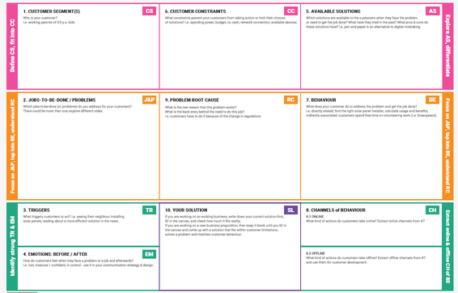

References:
- https://www.ideahackers.network/problem-solution-fit-canvas/
- https://medium.com/@epicantus/problem-solution-fit-canvas-aa3dd59cb4fe

4.2 Proposed Solution
Proposed Solution Template

Date | 15 February 2025
Team ID

Project Name

Maximum Marks | 2 Marks

Proposed Solution Template:
Project team shall fill the following information in the proposed solution template.
S.No. | Parameter | Description
 | Problem Statement (Problem to be solved)
 | Idea / Solution description
 | Novelty / Uniqueness
 | Social Impact / Customer Satisfaction
 | Business Model (Revenue Model)
 | Scalability of the Solution

4.3 Solution Architecture
Solution Architecture
Date | 15 February 2025
Team ID

Project Name

Maximum Marks | 4 Marks

Solution Architecture:
Solution architecture is a complex process – with many sub-processes – that bridges the gap between business problems and technology solutions. Its goals are to:
- Find the best tech solution to solve existing business problems.
- Describe the structure, characteristics, behavior, and other aspects of the software to project stakeholders.
- Define features, development phases, and solution requirements.
- Provide specifications according to which the solution is defined, managed, and delivered.

Example - Solution Architecture Diagram:

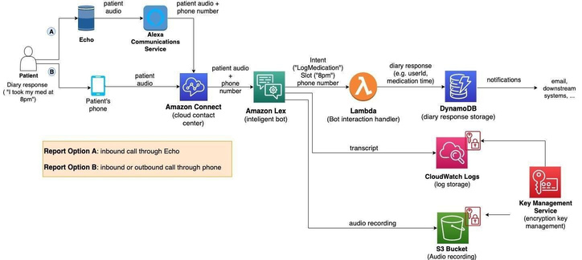

Figure 1: Architecture and data flow of the voice patient diary sample application
Reference: https://aws.amazon.com/blogs/industries/voice-applications-in-clinical-research-powered-by-ai-on-aws-part-1-architecture-and-design-considerations/
5. PROJECT PLANNING & SCHEDULING
5.1 Project Planning
Planning logic
A Sprint fixed period or duration in which a team works to complete a set of tasks
An Epic is a big task or project that is too large to complete in one sprint. It is broken down into smaller tasks (stories) that can be completed over multiple sprints.
A Story is a small task . It is part of an Epic.
A Story Point is a number that represents how much effort a story takes to complete. (usually in form of Fibonacci series)
- Very Easy task
- Normal task
- Moderate task
- Difficult task

Storypoint -5 (1,2,3,5)

Sprint 1
Data Collection (Epic 1)
Gathering Data (USN1) 2
Loading Data(USN2) 1
Data Preparation (Epic 2)
Handling Missing Values(USN3) 3
Creating Fields(USN4)3
Handling Inconsistency in Data(USN5)3
Total Story Point in Sprint 1= 2+1+3+3+3=12

Sprint 2
Data Visualization (Epic 3)
Bar Chart(USN6) 2
Pie Chart(USN7) 2
Line Chart(USN8) 2
Map(USN9) 4

Dashboard (Epic 4)
Developing Dashboard(USN10) 5
Story (Epic 5)
Developing Story(USN11) 5

Total story Point in Sprint 2= 2+2+2+4+5+5=20

Total Story Points
Sprint 1 = 12
Sprint 2 = 20

Velocity= Total Story Points Completed​/ Number of Sprints
Total story Points= 12+20=32
No of Sprints= 2
Velocity =32/2
16(Story Points per Sprint)
Your team’s velocity is 16 Story Points per Sprint.
Project Planning Template (Product Backlog, Sprint Planning, Stories, Story points)

Date | 15 February 2025
Team ID

Project Name

Maximum Marks | 5 Marks

Product Backlog, Sprint Schedule, and Estimation (4 Marks)
Use the below template to create product backlog and sprint schedule
Sprint | Functional Requirement (Epic) | User Story Number | User Story / Task | Story Points | Priority | Team Members
Sprint-1 | Registration | USN-1 | As a user, I can register for the application by entering my email, password, and confirming my password. | 2 | High
Sprint-1 |  | USN-2 | As a user, I will receive confirmation email once I have registered for the application | 1 | High
Sprint-2 |  | USN-3 | As a user, I can register for the application through Facebook | 2 | Low
Sprint-1 |  | USN-4 | As a user, I can register for the application through Gmail | 2 | Medium
Sprint-1 | Login | USN-5 | As a user, I can log into the application by entering email & password | 1 | High
 | Dashboard

Project Tracker, Velocity & Burndown Chart: (4 Marks)
Sprint | Total Story Points | Duration | Sprint Start Date | Sprint End Date (Planned) | Story Points Completed (as on Planned End Date) | Sprint Release Date (Actual)
Sprint-1 | 20 | 6 Days | 24 Oct 2022 | 29 Oct 2022 | 20 | 29 Oct 2022
Sprint-2 | 20 | 6 Days | 31 Oct 2022 | 05 Nov 2022
Sprint-3 | 20 | 6 Days | 07 Nov 2022 | 12 Nov 2022
Sprint-4 | 20 | 6 Days | 14 Nov 2022 | 19 Nov 2022

Velocity:
Imagine we have a 10-day sprint duration, and the velocity of the team is 20 (points per sprint). Let’s calculate the team’s average velocity (AV) per iteration unit (story points per day)

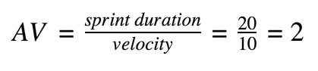

Burndown Chart:
A burn down chart is a graphical representation of work left to do versus time. It is often used in agile software development methodologies such as Scrum. However, burn down charts can be applied to any project containing measurable progress over time.

https://www.visual-paradigm.com/scrum/scrum-burndown-chart/
https://www.atlassian.com/agile/tutorials/burndown-charts

Reference:
https://www.atlassian.com/agile/project-management
https://www.atlassian.com/agile/tutorials/how-to-do-scrum-with-jira-software
https://www.atlassian.com/agile/tutorials/epics
https://www.atlassian.com/agile/tutorials/sprints
https://www.atlassian.com/agile/project-management/estimation
https://www.atlassian.com/agile/tutorials/burndown-charts

6. FUNCTIONAL AND PERFORMANCE TESTING
6.1 Performance Testing
Model Performance Test

Date | 10 February 2025
Team ID | PNT2022TMIDxxxxxx
Project Name | Project - xxx
Maximum Marks

Model Performance Testing:
Project team shall fill the following information in model performance testing template.
S.No. | Parameter | Values | Screenshot
 | Model Summary | -
 | Accuracy | Training Accuracy - Validation Accuracy -
3. | Fine Tunning Result( if Done) | Validation Accuracy -

Functional & Performance Testing Template
Model Performance Test

Date | 21 February 2025
Team ID | PNT2022TMIDxxxxxx
Project Name | Project - xxx
Maximum Marks

Test Scenarios & Results
Test Case ID | Scenario (What to test) | Test Steps (How to test) | Expected Result | Actual Result | Pass/Fail
FT-01 | Text Input Validation (e.g., topic, job title) | Enter valid and invalid text in input fields | Valid inputs accepted, errors for invalid inputs
FT-02 | Number Input Validation (e.g., word count, size, rooms) | Enter numbers within and outside the valid range | Accepts valid values, shows error for out-of-range
FT-03 | Content Generation (e.g., blog, resume, design idea) | Provide complete inputs and click "Generate" | Correct content is generated based on input
FT-04 | API Connection Check | Check if API key is correct and model responds | API responds successfully
PT-01 | Response Time Test | Use a timer to check content generation time | Should be under 3 seconds
PT-02 | API Speed Test | Send multiple API calls at the same time | API should not slow down
PT-03 | File Upload Load Test (e.g., PDFs) | Upload multiple PDFs and check processing | Should work smoothly without crashing

Model Performance Test

Date | 10 February 2025
Team ID | PNT2022TMIDxxxxxx
Project Name | Project - xxx
Maximum Marks | 10 Marks

Model Performance Testing:
Project team shall fill the following information in model performance testing template.
S.No. | Parameter | Values | Screenshot
 | Metrics | Regression Model:MAE - , MSE - , RMSE - , R2 score -Classification Model:Confusion Matrix - , Accuray Score- & Classification Report -
 | Tune the Model | Hyperparameter Tuning - Validation Method -

Model Performance Test

Date | 10 February 2025
Team ID | PNT2022TMIDxxxxxx
Project Name | Project - xxx
Maximum Marks

Model Performance Testing:
Project team shall fill the following information in model performance testing template.
S.No. | Parameter | Screenshot / Values
 | Data Rendered
 | Data Preprocessing
3. | Utilization of Data Filters
4. | DAX Queries Used
5. | Dashboard design | No of Visualizations / Graphs -
6 | Report Design | No of Visualizations / Graphs -

Model Performance Test

Date | 21 February 2025
Team ID | PNT2022TMIDxxxxxx
Project Name | Project - xxx
Maximum Marks

Model Performance Testing:
Project team shall fill the following information in model performance testing template.
S.No. | Parameter | Values | Screenshot
 | Model Summary | Salesforce automation setup for Data management using Object, Fields and Reports.Note : Import Records if data Match Correctly then Records will Created or Else it will Show Error | 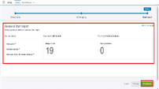
 | Accuracy | Training Accuracy - 98%Validation Accuracy - 98% | 
3. | Confidence Score (Only Yolo Projects) | Class Detected - If detecting Object and fields name if wrong and other activityConfidence Score - If the model is 92% sure the object is correctly detected |   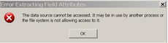

Performance Test

Date | 10 February 2025
Team ID | PNT2022TMIDxxxxxx
Project Name | Project - xxx
Maximum Marks

Model Performance Testing:
Project team shall fill the following information in model performance testing template.
S.No. | Parameter | Screenshot / Values
 | Data Rendered
 | Data Preprocessing
3. | Utilization of Filters
4. | Calculation fields Used
5. | Dashboard design | No of Visualizations / Graphs -
6 | Story Design | No of Visualizations / Graphs -
User Acceptance Testing (UAT) Template
Date

Team ID

Project Name

Maximum Marks

Project Overview:
Project Name: [Enter Project Name]
Project Description: [Brief Description of the Project]
Project Version: [Version Number]
Testing Period: [Start Date] to [End Date]
Testing Scope:
[List of Features and Functionalities to be Tested]
[List of User Stories or Requirements to be Tested]
Testing Environment:
URL/Location: [Web URL or Application Location]
Credentials (if required): [Username/Password]
Test Cases:
Test Case ID | Test Scenario | Test Steps | Expected Result | Actual Result | Pass/Fail
TC-001 | [Describe the scenario to be tested] | [Step 1]  [Step 2]  [Step 3] | [Describe the expected outcome] | [Record the actual outcome] | [Pass/Fail]
... | ... | ... | ... | ... | ...

Bug Tracking:
Bug ID | Bug Description | Steps to reproduce | Severity | Status | Additional feedback
BG-001 | [Describe the issue or bug encountered] | [Step 1]  [Step 2]  [Step 3] | [Low/Medium/High] | [Open/In Progress/Closed] | [Any additional comments or feedback]
... | ... | ... | ... | ... | ...

Sign-off:
Tester Name: [Name of Tester]
Date: [Date of Test Completion]
Signature: [Tester's Signature]
Notes:
- Ensure that all test cases cover both positive and negative scenarios.
- Encourage testers to provide detailed feedback, including any suggestions for improvement.
- Bug tracking should include details such as severity, status, and steps to reproduce.
- Obtain sign-off from both the project manager and product owner before proceeding with deployment.
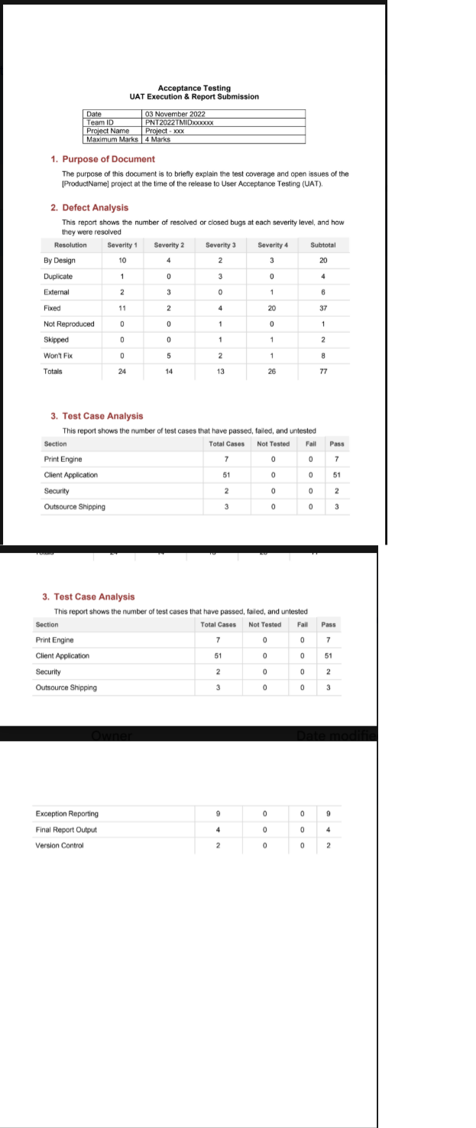

7. RESULTS
7.1 Output Screenshots

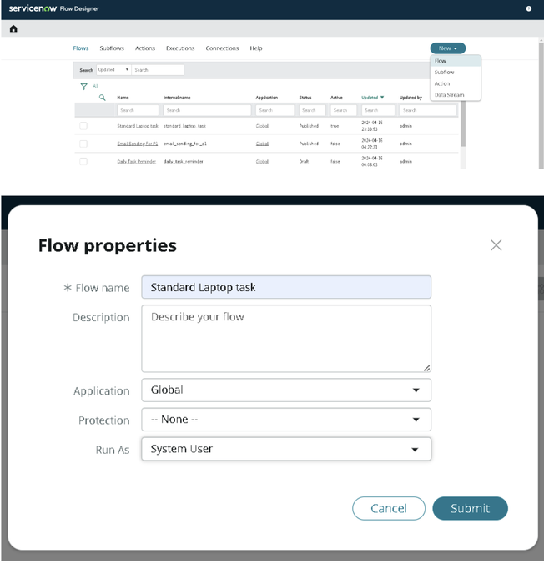

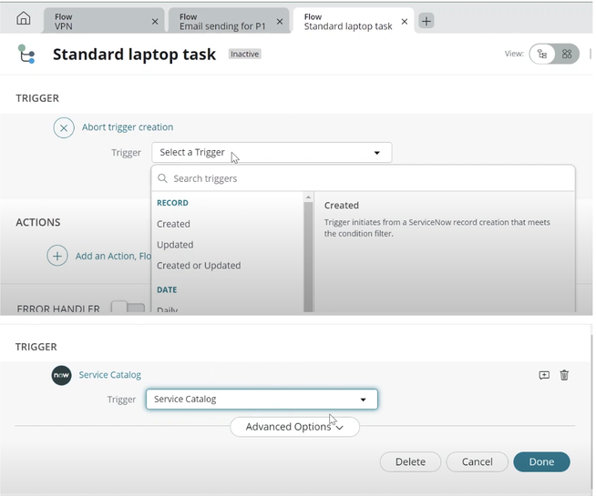

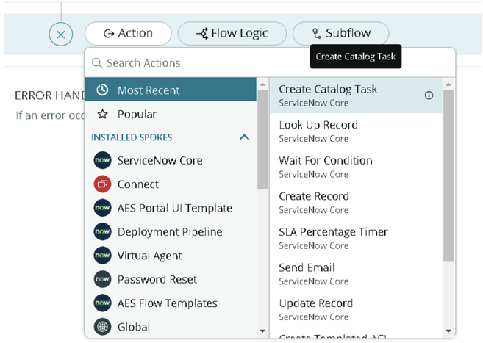

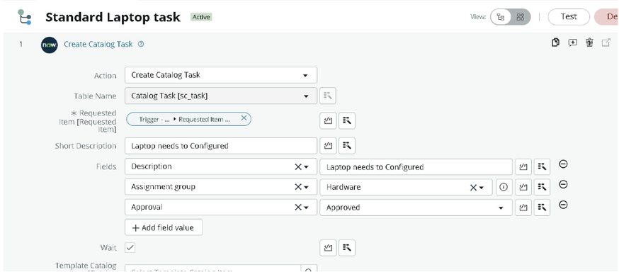

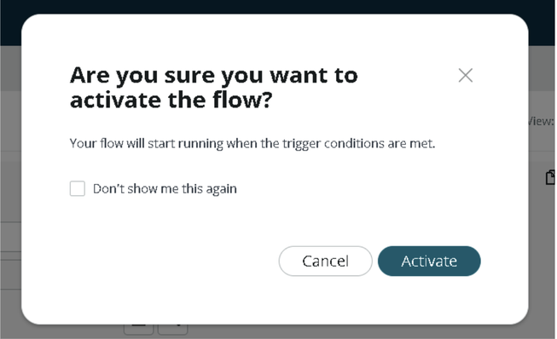

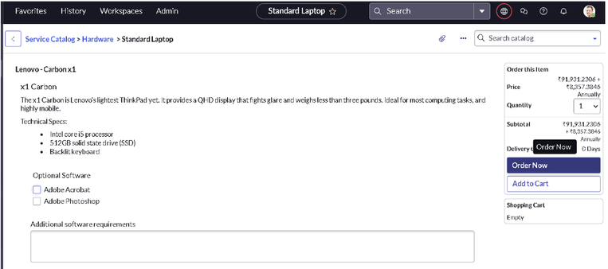

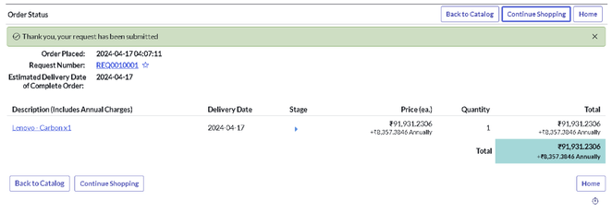

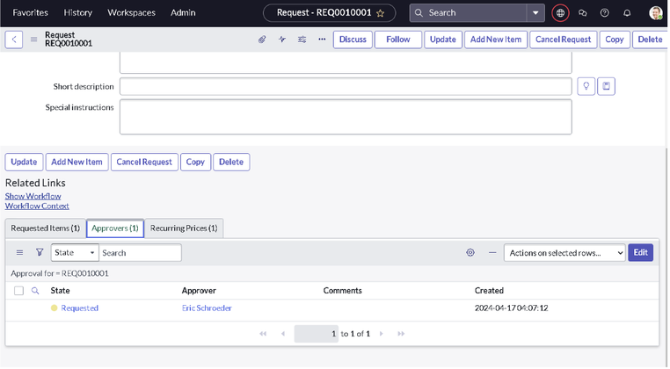

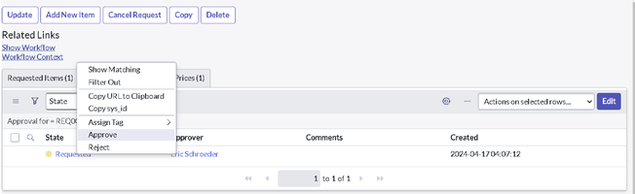

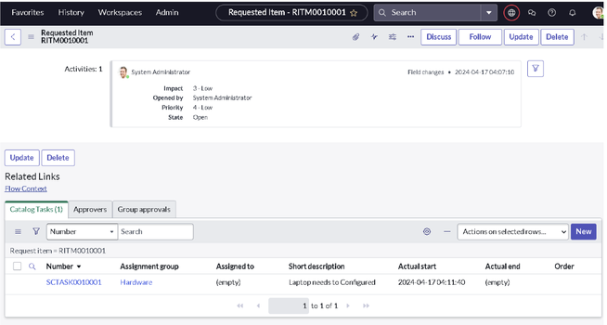

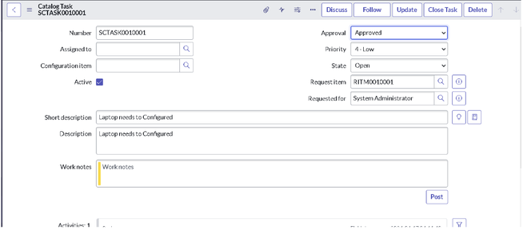

8. ADVANTAGES & DISADVANTAGES
8.1 Advantages
The project “Streamlining IT Procurement: Automating Standard Laptop Orders with Flow Designer” provides several advantages by automating the standard laptop ordering process using ServiceNow Flow Designer.
1. Reduces Manual Work: Automation reduces the need for employees to perform repetitive tasks manually, such as routing requests and sending status notifications.
2. Faster Request Processing: Automated workflows help process laptop requests more efficiently by moving requests through predefined stages without unnecessary delays.
3. Improved Accuracy: Standardized workflow conditions help minimize human errors and ensure that requests are processed according to predefined rules.
4. Automated Approval Management: Laptop requests can be automatically routed to the appropriate approvers, making the approval process more organized and efficient.
5. Better Communication: Automated notifications keep requesters, approvers, and IT procurement teams informed about request progress and approval decisions.
6. Improved Transparency: The workflow allows users and authorized teams to monitor request statuses and understand the progress of each order.
7. Increased Productivity: IT and procurement employees can focus on more important responsibilities instead of spending time on repetitive administrative activities.
8. Low-Code Development: ServiceNow Flow Designer provides a visual interface for designing workflows with minimal programming knowledge.
9. Standardized Process: Every laptop request can follow the same predefined process, ensuring consistency across the organization.
10. Easy Maintenance: Workflow conditions and actions can be modified when procurement policies or organizational requirements change.
8.2 Disadvantages
Although the proposed system provides several benefits, it also has certain limitations.
1. Initial Configuration Effort: Designing and configuring the workflow requires time, planning, and knowledge of the ServiceNow platform.
2. Platform Dependency: The automation depends on ServiceNow and its availability. Platform outages or technical issues may interrupt workflow execution.
3. Limited Flexibility for Complex Requests: Standard workflows may require additional conditions or custom development to handle unusual laptop requests or special procurement requirements.
4. Integration Requirements: Connecting the workflow with external procurement, inventory, or financial systems may require additional configuration and integration.
5. Maintenance Requirements: The workflow must be reviewed and updated whenever organizational policies, approval rules, or system configurations change.
6. User Training: Employees and administrators may require training to understand the request process and use the ServiceNow system effectively.
7. Configuration Errors: Incorrectly configured triggers, conditions, approvals, or actions may cause requests to be delayed or processed incorrectly.
8. Access and Security Management: Appropriate user roles and permissions must be configured to prevent unauthorized access to procurement requests and related information.
Despite these limitations, proper configuration, testing, security controls, and regular maintenance can help ensure that the automated procurement workflow operates effectively.

9. CONCLUSION
The project “Importing Data Using Transform Maps (Spreadsheet) in ServiceNow” successfully demonstrates how organizations can leverage ServiceNow’s Import Set architecture to manage bulk data efficiently. By replacing manual entry pipelines with automated Transform Maps, the system guarantees a structured, secure, and rapid methodology for updating system records.
Through the configuration of explicit field mappings, coalesce keys, and source-to-target rules, the project addresses core data-management risks such as data duplication and format corruption. The visual, low-code interface of Transform Maps allows platform administrators to handle complex sheet architectures with minimal script overhead, reducing deployment timelines for data migration.
Ultimately, this automation shifts data maintenance from an error-prone administrative chore to a systematic background utility. With a well-configured transform mapping strategy, organizations can keep their ServiceNow instance accurate, integrated, and ready to support day-to-day operations with clean, highly reliable data assets.
10. FUTURE SCOPE
The capabilities of this data import framework can be expanded in the future through advanced integrations and automated scheduling mechanisms:
• Scheduled Data Imports: Integrate with external file hosting services (like SFTP, SharePoint, or AWS S3) to automatically fetch and transform spreadsheets on a daily or weekly cron loop.
• Robust Robust Transform Engine (RTE): Transition to ServiceNow's Robust Transform Engine (RTE) for highly complex multi-table mappings that require advanced processing logic over standard transform maps.
• AI-Powered Field Matching: Incorporate predictive models to automatically read spreadsheet headers and suggest the most accurate destination fields in the target tables.
• Automated Failure Notifications: Configure immediate workflow notifications (via email or Slack) to alert administrators with exact error logs whenever an import row fails validation.
• Excel Template Generator: Develop an automated utility that dynamically creates and downloads blank spreadsheet templates based on the destination table's active schema.
• Data Privacy Masking: Implement data obfuscation scripts within the transform mapping layer to automatically mask sensitive PII data before it enters staging tables.

11. APPENDIX
GitHub:
Project Demo Link:

